A FOOD Exercise – What’s in a common food?

We need to eat a wide variety of foods to provide our bodies with all the substances that are needed. When we do this, we are said to have a balanced diet.

Substance needed | Examples | Why it’s needed | Good sources
carbohydrate | starch, sugars | for respiration to release energy | pasta, bread
Fat |  | For storage as energy backup. | Dairy, Meat, fast food.
protein |  | for growth and repair | meat, beans
vitamins | vitamin C | To participate in biological processes within the body | fruits and vegetables – oranges contain a lot vitamin C
minerals | calcium | To build specific molecules such as Haemoglobin and Calcium Carbonate | fruits, vegetables and dairy products – milk contains a lot of calcium
fibre |  | for health; helps to keep our intestines clean stop them getting blocked up (constipation) | wholemeal bread
water |  | for health; water is important solvent in the body | All foods

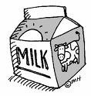
Scientific Inquiry: Let’s have a look at a common food - MILK
Nutritional Composition : Fresh Whole Milk ( per 100g )
Energy | 272 kJ
Carbohydrate | 4.7 g
Fat | 4.8 g
Protein | 3.3 g
Fibre | Nil
Sodium | 50 mg
Vitamin C | 1.5 mg

- How much protein is there in 100 g of milk ?
- How much energy is there in a glass (200ml) of milk ?
- How much milk do you need to drink to get the Recommended Daily Allowance (RDA) of vitamin C (30mg) ?
- Calculate what volume of milk will take you over the daily limit of 6g ?
- What nutrient is not listed ?
- What is in the table that is NOT a nutrient ?

Overview of Digestion

To make use of the food, our bodies need to break it up into smaller sized molecules. This is called digestion. Digestion turns large insoluble substances into small soluble ones. The organs of the digestive system help us digest food. Some of the organs (the mouth and the stomach) physically break the food down. This is called Mechanical digestion. Other organs (the mouth, Stomach, Liver, Pancreas, and Small Intestine) them produce enzymes (chemicals) that chemically break up food. This is called Chemical digestion
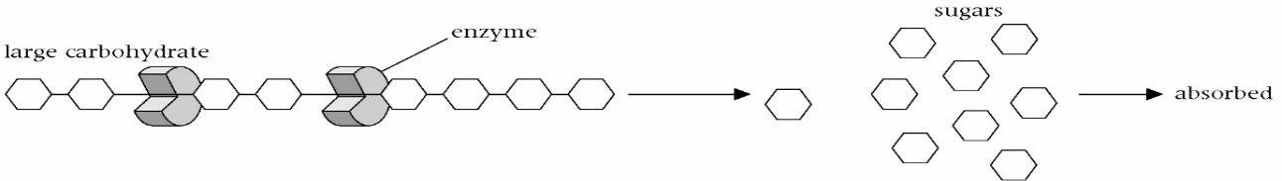
The Gastrointestinal Tract

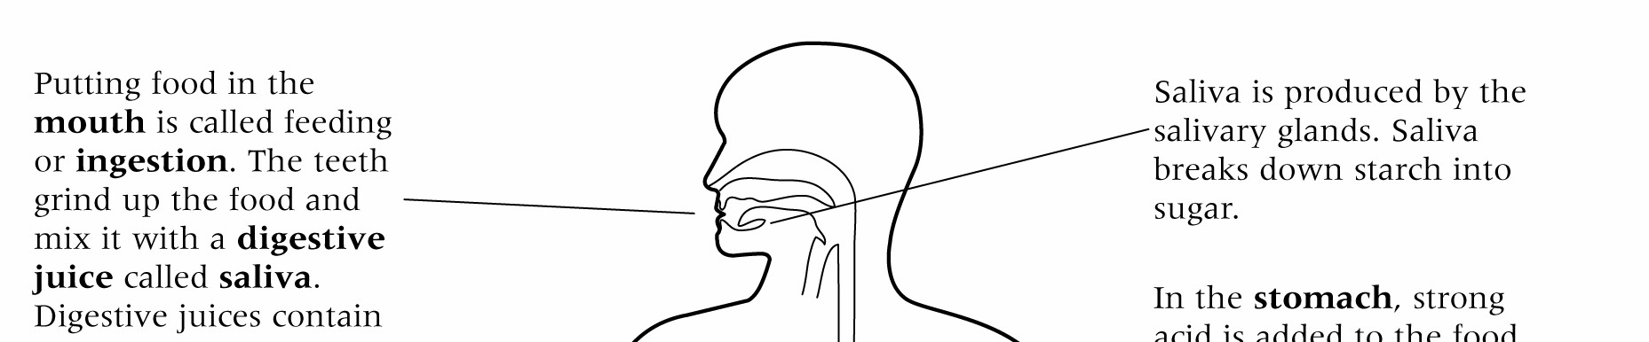
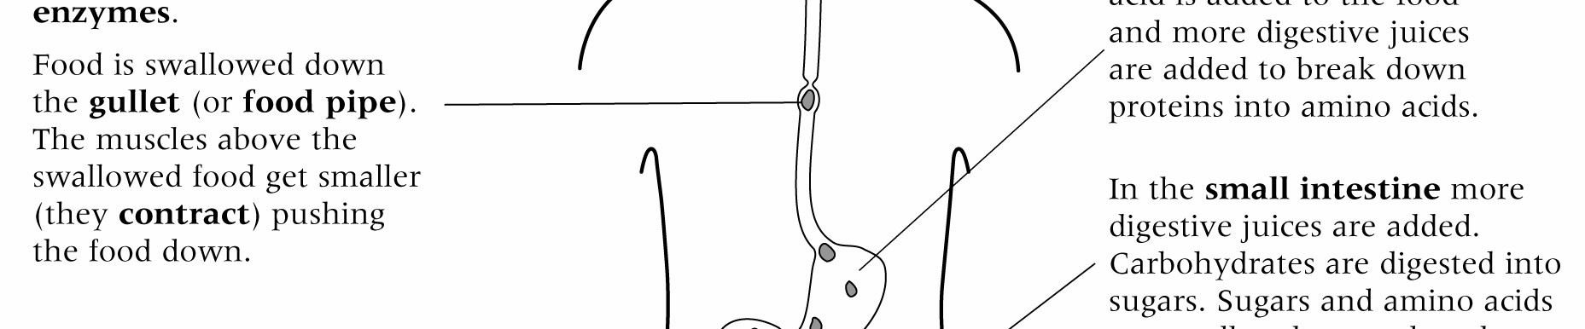
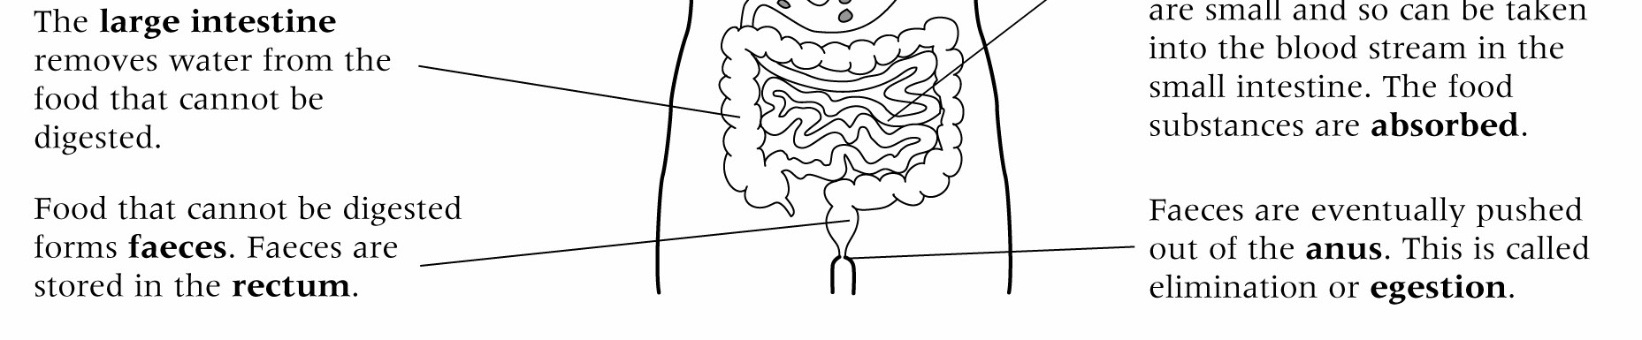
The Gastrointestinal Tract (GIT)
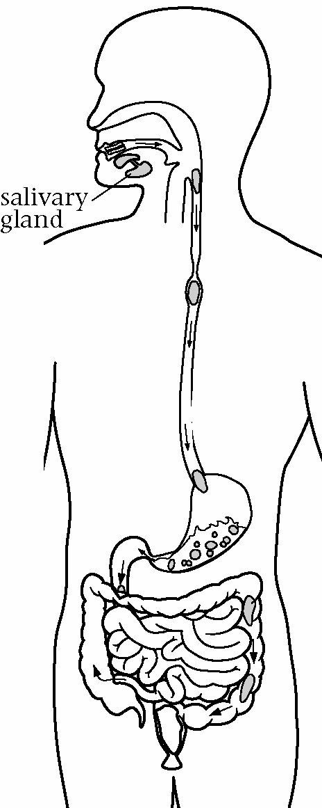
In the GastoIntestinal Tract (GIT)

- Label the parts of the digestive system on the diagram below. Use these letters as your labels:

  - – the large intestine
  - – where small, soluble molecules are taken into the body (absorbed)
  - – where faeces are stored
  - – this organ contains a strong acid
  - – the gullet
  - – where feeding happens
  - – the anus

- The answer to each of these questions in one of the letters in question
  - Saliva is produced here. _________________________
  - This is called the small intestine. _________________________
  - Faeces are eliminated (or egested) here.________________________
  - Food travels from the mouth to the stomach here._________________
  - Water is removed from undigested food here.____________________
  - This is called the stomach. _________________________
  - This is called the rectum. _________________________

- Enzymes are chemicals that chop up large molecules into smaller ones.
There are enzymes in the small intestine. Explain why these are needed.

Digestion

absorbed | anus | enzymes | intestine
juices | mouth | insoluble | soluble

Digestion makes ________________ substances into ______________ ones.
This process starts in the __________________. During digestion, digestive ________________ are added to the food. These contain ______________ .
When the food that can be digested has been broken down, it is _____________ by the small _________________. Food that cannot be broken down is passed out of the body through _________________.

Quick Quiz
- A food substance found in many foods is:
  - carbohydrate. B chalk. C energy. D carbon dioxide.

- One of the ways in which water is used by the body is as:
  - a source of fibre. B a source of energy. C a solid. D a solvent.

- Fibre in your diet helps to stop:
  - you lying. B scurvy. C constipation. D digestion.

- You have a balanced diet when:
  - the mass of all the food you eat in a day adds up to 100 kg.
  - the mass of all the food you eat one day is equal to the mass you eat the next day.
  - you eat a wide range of different foods to give your body all the things it needs.
  - you only eat fish on Fridays.

- Meats are a good source of which food substance?
A fibre B protein C oxygen D vitamins

- Why do we need protein in our food?
  - It is a good source of energy.
  - It is used for growth and repair.
  - It is full of vitamins.
  - It helps food to pass through the GIT smoothly.

- Which organ is labelled X in the drawing below?
A small intestine B stomach

C liver D mouth

- In the diagram above what does the organ labelled X do?
- It mixes up food with acid and breaks down proteins.
- It adds vitamins to the food.
- It takes the water out of the food.
- It stores waste food until it can be got rid of.

- In digestion:
- soluble food substances are made into insoluble ones.
- insoluble food substances are broken up into soluble ones.
- food is stored inside the body until it is needed.
- D waste food is removed from the body.

- The main chemicals used to digest foods are:
- vitamins. B salivas. C digestifs. D enzymes.


- Which label shows the place where digested food is taken into the blood?
- When digested food is taken into the blood it is said to be:
  - egested. B ingested. C absorbed. D insoluble.

- Digested food is carried around the body in the:
A digestive system. B circulatory system. C breathing system. D nervous system.

- What is the digested food used for inside our bodies?
  - to provide energy only
  - to provide energy and chemicals to make new substances
  - to help us go to the toilet more easily
  - to provide substances to make sure that the blood does not become too runny

DIGESTION CROSSWORD

 |  |  | 1 |  |  |  |  |  |  |  |  |  |  |  |  |  |  | 2
 |  | 3 |  |  |  |  |  |  |  | 4
 |  |  |  |  |  |  | 5 |  |  |  |  | 6 |  |  |  | 7
 |  |  |  |  |  |  |  |  |  |  |  |  |  | 8
9 |  |  |  |  | 10
 |  |  | 11 |  |  |  | 12
 |  |  |  |  |  |  |  |  |  | 13
14 | 15 |  |  |  |  | 16 |  | 17
 |  |  |  |  |  |  |  |  |  |  |  |  |  |  | 18
 |  |  |  |  |  |  |  |  |  | 19
20
 |  |  |  |  | 21 |  | 22
 |  | 23
 |  |  |  | 24

ACROSS
3 Food substance used for energy.
5 The substance that is used in all cells to release energy from.
- Breathing out carbon dioxide is an example of this life process.
- Process that cells use to release energy.
- Calcium is one of these.
- Food substance that helps clean your intestines.
- Food substance that is needed for good health.
- Food is absorbed here.
- Unit of energy found on food packets.

DOWN
- Name of a digestive juice.
- Process used to break apart food.
4 Faeces are stored here.
- Organ containing a strong acid.

- Food substance used for growth and repair.
- Tube carrying food from the mouth to the stomach.
- Food substance that makes things taste sweet.
- A product of respiration.
- Very small tube that carries blood.
- Food substance stored in the body to provide energy in the future.
- Substance used to break down food.
- Getting rid of waste food that cannot be digested.
- Tube that carries blood away from the heart.
- Putting food into your mouth.
- We need to eat a wide variety of foods to get a diet that is ______________.
21 The small intestine is lined with these.

